How different companies stock data has been changed throughout the years have been shown using the interactive dashboard from shiny - R.

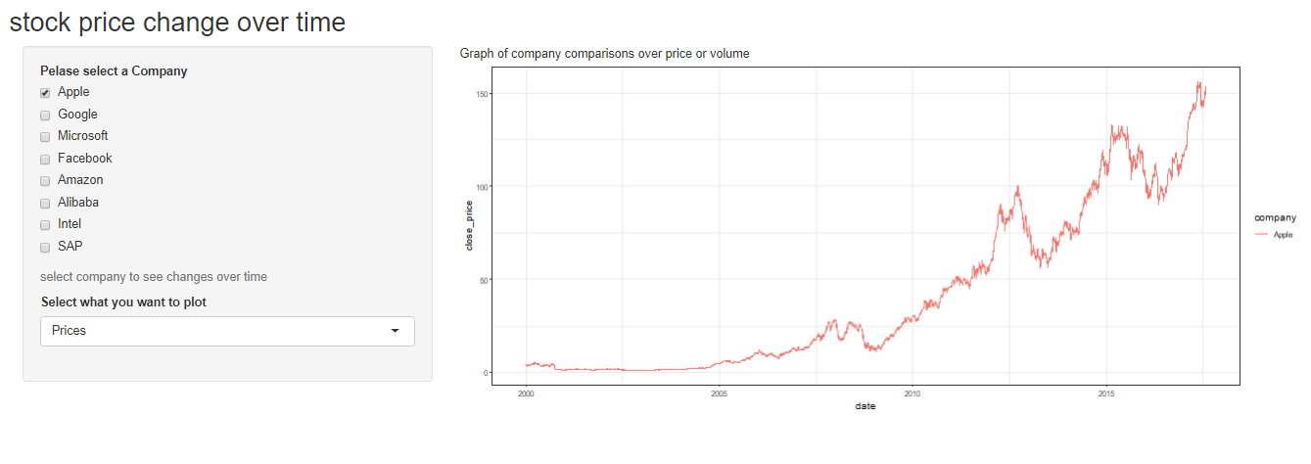

Interactive shiny app has been generated to let user compare either prices or share volume of their desired stocks over time. Here line chart is used to show the changes over time. coloring has been done to differentiate between different stocks. Users can select any amount of stocks they desire and can select what they want to compare price or volume. The selection of company is of checkbox where selecting the company generates line graph for the appropriate line chart selection. Appropriate title for sidebar panel, graph panel, axis label and input labels has been given.